**Project Name: Gym Locater And Booking**

**Project Member:**

**Tarun kumar 210543181111**

**Anmol Gangil 210543181008**

**Rohit Sharma 210543181081**

**Bhushan Rajan Ghodeswar  210543181027**

**Abstract:**

How can Gym locator and booking help in choosing the best gyms in your city?

You can search for gyms in your city based on member ratings, offers, affordable prices, location, popularity, distance, facilities on our website. You can also book a free trial or buy a gym membership on India’s leading &amp; largest fitness discovery platform. Gym locator and booking has most of the India’s fitness chains like Gold’s Gym, Power World Gyms, Snap Fitness, Anytime Fitness, CrossFit, etc. on its fitness discovery platform.

If you are going to search for a gym or planning to join a gym, you can check with the gym management if they already have personal training facility so that you can avail the trainings at an extra cost. You can also check if they have any kind of plans for personal training.

The main objective of Gym locator and booking system is to manage the details of Gym location, contacts, Gym location, various offers and contact of Gym faculty member provided by the gym. You can book your favorite gym online through this website.

**Implementation Technologies:**

1. **Spring Boot:**

Spring Boot is an open source Java-based framework used to create a micro Service. It is developed by Pivotal Team and is used to build stand-alone and production ready spring applications.

Spring Boot provides a good platform for Java developers to develop a stand-alone and production-grade spring application that you can just run. You can get started with minimum configurations without the need for an entire Spring configuration setup.

**Spring Boot Features**

* Web Development
* Spring Application
* Application events and listeners
* Admin features
* Externalized Configuration
* Properties Files
* YAML Support
* Type-safe Configuration
* Logging
* Security

### Advantages

Spring Boot offers the following advantages to its developers −

* Easy to understand and develop spring applications
* Increases productivity
* Reduces the development time

1. **Hibernate:**

Hibernate's primary feature is mapping from Java classes to database tables, and mapping from Java data types to SQL data types. Hibernate also provides data query and retrieval facilities. It generates SQL calls and relieves the developer from the manual handling and object conversion of the result set.

**Features of hibernate:**

* It provides a feature of J2EE integration.
* At system initialization time, it generates SQL.
* Optionally provide internal connection pooling and prepared statement caching.
* It supports optimistic locking with versioning.
* It provides outer join fetching.
* It introduces Lazy initialization.
* It provides session-level cache and optional second-level cache.
* It provides Dual-layer Cache Architecture.
* Automatic generation of the primary key.
* It supports the tough concept of composite keys.
* It supports the Detached object concept.
* It introduces the automatic Dirty Checking concept.

1. **Thymeleaf:**

Thymeleaf is a Java XML/XHTML/HTML5 template engine that can work both in web (servlet-based) and non-web environments. It is better suited for serving XHTML/HTML5 at the view layer of MVC-based web applications, but it can process any XML file even in offline environments.

**Features of Thymeleaf:**

It works on both web and non-web environments.

* Java template engine for HTML5/ XML/ XHTML.
* Its high-performance parsed template cache reduces I/O to the minimum.
* It can be used as a template engine framework if required.
* It supports several template modes: XML, XHTML, and HTML5.
* It allows developers to extend and create custom dialect.
* It is based on modular features sets called dialects.
* It supports internationalization.

**4. Hyper Text Markup Language(HTML):**

HTML definition is Hyper Text Markup Language and it is a markup language. A markup language is a set of markup tags and the tags describe document content. HTML documents contain HTML tags and plain text. HTML documents are also called web pages.MySQL

## ****HTML Tags:****

HTML markup tags are usually called HTML tags and tags are keywords surrounded by angle brackets like <html>. These tags are also called as basic html elements. HTML tags normally come in pairs like <b> and </b>. The first tag in a pair is the start tag, the second tag is the end tag. The end tag is written like the start tag, with a forward slash before the tag name. Start and end tags are also called opening tags and closing tags. By using these tags we can create a simple HTML page very easily.

## ****Features of HTML:****

HTML is the most common used language to write web pages. It has recently gained popularity due to its advantages such as: -

1. It is the language which can be easily understood and can be modified.
2. Effective presentations can be made with the HTML with the help of its all formatting tags.
3. It provides the more flexible way to deign web pages along with the text.
4. Links can also be added to the web pages so it helps the readers to browse the information of their interest.
5. You can display HTML documents on any platforms such as Macintosh, Windows and Linux etc.
6. Graphics, videos and sounds can also be added to the web pages which give an extra attractive look to your web pages.

### 5.Bootstrap 4

This year, 2018, the newest version of Bootstrap has been introduced. It has been named "Bootstrap 4." This version has been claimed to be a newer and more advanced version of the previous version, "Bootstrap 3."

## Features of Bootstrap

Bootstrap has a lot of features. These features not only make it stand out, but they also make it more popular even among those web designers who like to take things in a very conventional way.

### 1. Easy to Begin With

It is pretty easy, to begin with. Being easy to get started with is probably the first quality which makes Bootstrap very appealing.

### 2. LESS as Well as CSS Files

Bootstrap not only offers LESS files but also includes the old CSS files.

### 3. Easily Customizable

Despite the fact that Bootstrap is designed in responsive 12-column grids, layouts, and components, it is also very easy to customize. Whether you need a fixed grid or a responsive one, it can be made possible by making a few changes. Offsetting and nesting of columns are also easy to do in both CPU-based and mobile-based browser grids.

### 4. Responsive Utility Classes

Another prominent feature of Bootstrap is its responsive utility classes. Using responsive utility classes, a particular piece of content can be made to appear or hide only on devices depending on the size of the screen being used. This feature is extremely helpful for designers who want to make a mobile and tablet-friendly version of their websites.

### 5. Components of Bootstrap

Some of the components that come pre-styled in Bootstrap are:

* Drop-downs
* Button
* Navigation
* Badges Alerts
* Progress Bar

### 6. Drop-Down Component Menu

The drop-down component menu is a responsive additive feature of a website. To include it in a website, a lot of different plugins, mostly Java-based, are tested. But, via Bootstrap and its easy customizing options, this can easily be done in a matter of minutes.

### 7. Bootstrap Templates

The readily available templates make it easier for inexperienced users to create a website following a simple tutorial or demo available on the Bootstrap.

**6.Cascading Style Sheets(CSS):**

Cascading Style Sheets, fondly referred to as CSS, is a simple design language intended to simplify the process of making web pages presentable.

CSS handles the look and feel part of a web page. Using CSS, you can control the color of the text, the style of fonts, the spacing between paragraphs, how columns are sized and laid out, what background images or colors are used, layout designs, variations in display for different devices and screen sizes as well as a variety of other effects.

CSS is easy to learn and understand but it provides powerful control over the presentation of an HTML document. Most commonly, CSS is combined with the markup languages HTML or XHTML.

## Advantages of CSS:

* **CSS saves time** − You can write CSS once and then reuse same sheet in multiple HTML pages. You can define a style for each HTML element and apply it to as many Web pages as you want.
* **Pages load faster** − If you are using CSS, you do not need to write HTML tag attributes every time. Just write one CSS rule of a tag and apply it to all the occurrences of that tag. So less code means faster download times.
* **Easy maintenance** − To make a global change, simply change the style, and all elements in all the web pages will be updated automatically.
* **Superior styles to HTML** − CSS has a much wider array of attributes than HTML, so you can give a far better look to your HTML page in comparison to HTML attributes.
* **Multiple Device Compatibility** − Style sheets allow content to be optimized for more than one type of device. By using the same HTML document, different versions of a website can be presented for handheld devices such as PDAs and cell phones or for printing.
* **Global web standards** − Now HTML attributes are being deprecated and it is being recommended to use CSS. So its a good idea to start using CSS in all the HTML pages to make them compatible to future browsers.

# MySQL :

MySQL is a relational database management system (RDBMS) based on the SQL (Structured Query Language) queries. It is one of the most popular languages for accessing and managing the records in the table. MySQL is open-source and free software under the GNU license. Oracle Company supports it.

**Features of MYSQL:**

* **Easy to use** - MySQL is easy to use. We have to get only the basic knowledge of SQL. We can build and interact with MySQL by using only a few simple SQL statements.
* **It is secure** - MySQL consists of a solid data security layer that protects sensitive data from intruders. Also, passwords are encrypted in MySQL.
* **Client/ Server Architecture** - MySQL follows the working of a client/server architecture. There is a database server (MySQL) and arbitrarily many clients (application programs), which communicate with the server; that is, they can query data, save changes, etc.
* **It is scalable** - MySQL supports multi-threading that makes it easily scalable. It can handle almost any amount of data, up to as much as 50 million rows or more. The default file size limit is about 4 GB. However, we can increase this number to a theoretical limit of 8 TB of data.
* **Speed -** MySQL is considered one of the very fast database languages, backed by a large number of the benchmark test.
* **High Flexibility** - MySQL supports a large number of embedded applications, which makes MySQL very flexible.
  1. **Hardware and Software Requirements (Minimum):**

**Hardware:**

1. Intel i3 processor 7rd generation

2. 2 GB ddr3 ram.

3. Windows 10

4. 200 GB Sata HDD Space

5. Data Connection 200 kbps

**Software:**

1. Eclipse 4.17 2020-09
2. MySQL 5.7 with Workbench 8.0
3. Google Chrome version 93.0.4577.82
4. Maven Dependencies
   1. **ER Diagram:**

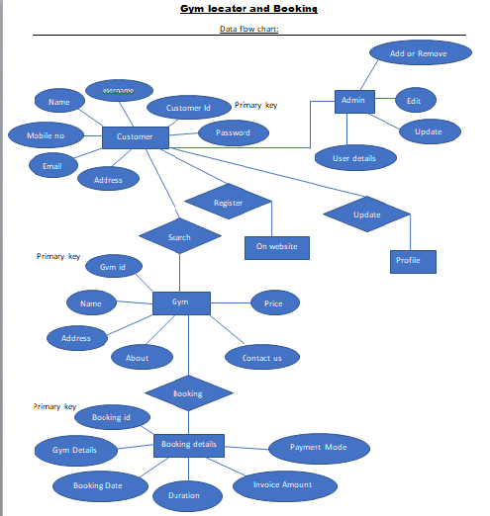

Figure 1: ER Diagram

1. **Table Structures:**
2. **Table name**: **gymregister**

|  | **Field** | **Type** | **Null** | **Key** | **Default** | **Extra** |
| --- | --- | --- | --- | --- | --- | --- |
|  | id | int | NO | PRI |  | auto_increment |
|  | aadhar | varchar(255) | YES |  |  |  |
|  | addressline | varchar(255) | YES |  |  |  |
|  | city | varchar(255) | YES |  |  |  |
|  | contact | varchar(255) | YES |  |  |  |
|  | country | varchar(255) | YES |  |  |  |
|  | fsname | varchar(255) | YES |  |  |  |
|  | gymemail | varchar(255) | YES |  |  |  |
|  | gymname | varchar(255) | YES |  |  |  |
|  | lsname | varchar(255) | YES |  |  |  |
|  | offer | varchar(255) | YES |  |  |  |
|  | offermonth | varchar(255) | YES |  |  |  |
|  | offeryear | varchar(255) | YES |  |  |  |
|  | pincode | varchar(255) | YES |  |  |  |
|  | price | double | YES |  |  |  |
|  | pwd | varchar(255) | YES |  |  |  |
|  | state | varchar(255) | YES |  |  |  |
|  | uname | varchar(255) | YES |  |  |  |
|  | member | varchar(255) | YES |  |  |  |

1. **Table name : user**

|  |  |  |  |  |  |
| --- | --- | --- | --- | --- | --- |
| id | int | NO | PRI |  | auto_increment |
| address | varchar(255) | YES |  |  |  |
| email | varchar(255) | YES |  |  |  |
| fname | varchar(255) | YES |  |  |  |
| gen | varchar(255) | YES |  |  |  |
| lname | varchar(255) | YES |  |  |  |
| password | varchar(255) | YES |  |  |  |
| phno | varchar(255) | YES |  |  |  |
| username | varchar(255) | YES |  |  |  |

1. **Table name : Booking**

|  |  |  |  |  |  |
| --- | --- | --- | --- | --- | --- |
| id | int | NO | PRI |  | auto_increment |
| gid | int | YES |  |  |  |
| uid | int | YES |  |  |  |
| membership | varchar(255) | YES |  |  |  |

1. **Table name : Trainer**

|  |  |  |  |  |  |
| --- | --- | --- | --- | --- | --- |
| id | int | NO | PRI |  | auto_increment |
| experience | varchar(255) | YES |  |  |  |
| gender | varchar(255) | YES |  |  |  |
| gymid | int | YES |  |  |  |
| trainername | varchar(255) | YES |  |  |  |

1. **UML Diagrams:**

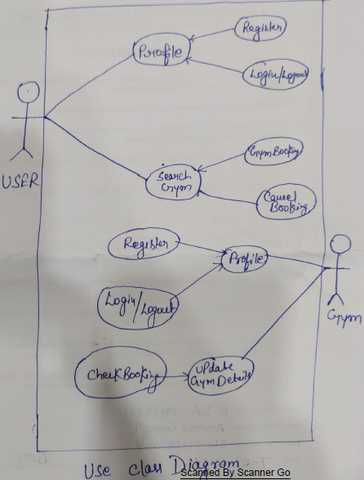

Figure 2: Use Case

1. **Collaboration Diagram :**

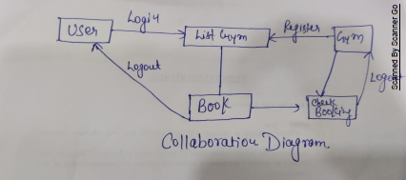

Figure 3: Collaboration Diagram

1. Sequence Diagram:

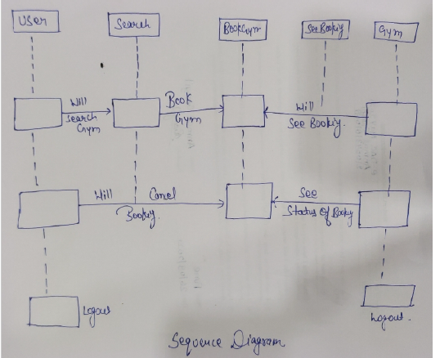

Figure 4: Sequence Diagram

4.Component Diagram

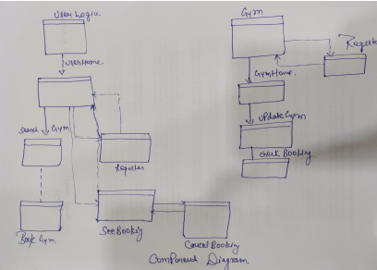

Figure 5: Component Diagram

**5.State Diagram:**

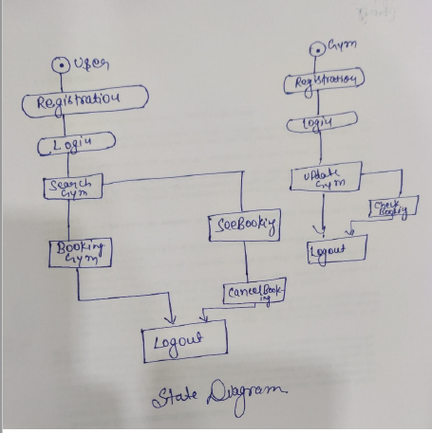

Figure 6: State Diagram

**6.Class Diagram:**

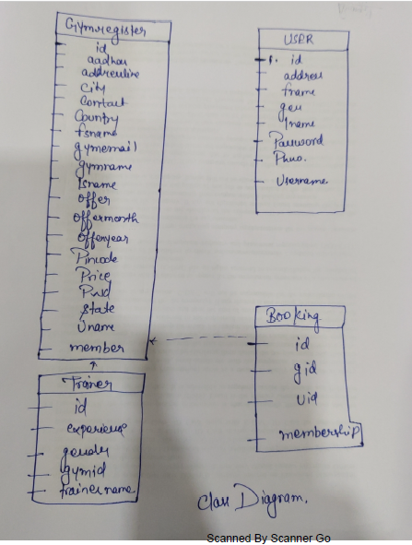

Figure 8: Class Diagram

1. **End to End Flow of Application:**

**User:**

* 1. User will login to the portal or will have to register if he is not a registered user.
  2. After registration User will login and User Home page will be displayed to him which will display the gym nearby his location by clicking allow button in notification.
  3. From that page can User will choose the gym according to his location and can click on the ‘**Details’** button and see the details of selected gym.
  4. After that user will check the details like Gym details, Offer Details, Trainer details etc.
  5. By clicking on “Book” button user will select the membership and click “yes” button for booking and “No” to go back.
  6. User will see his booking details on clicking “See your Booking Details” button and also on clicking “Dashboard” Button in navbar.

**GYM:**

1. Gym owner will login to the portal or will have to register if he is not a registered.
2. After registration Gym will login and Gym Home page will be displayed to him which will display the gym details.
3. There gym owner can update his gym details there he/she will update gym name, address, membership, trainer details.
4. Gym owner can see the bookings by clicking on ”Check” button.

**Thank You!**